**Project name: Domino’s**

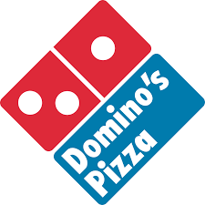

Logo image

#Home page:

*Logo

*Sign in

*Deal of the day

*Coupons

*Recommended combos

*In footer

-contact

-social media icon

-about

-terms and conditions

#Login page

*Name

*Email

*Contact

*Address

#Main menu

*Filters-(veg pizza,non-veg pizza,beverages,side orders,choice of crusts,choice of toppings,pasta,chicken items)

*Image of chosen one with details like-price,main ingredients,discount(if any)

*Restaurants near me-(nearest domino’s place)

*other recommended orders

#Payment page

*Address

*Payment method-(google pay,UPI,credit/debit card,etc.,)

#Github repository link:

https://github.com/merlia19/merlia192.git